**Title:** A comparison of WHO-HEAT model results using a non-linear physical activity dose response function with results from the existing tool.

**Authors:** Robert Smith1, Chloe Thomas1, Hazel Squires1 & Elizabeth Goyder1.

1 School of Health and Related Research, University of Shefﬁeld, Regents Court, UK, S1 4DA

**Corresponding Author:** Robert Smith (rasmith3@sheffield.ac.uk)

**Keywords:** Physical Activity, Dose Response Function, HEAT, Walking, Cycling.

**Acknowledgements:** The authors would like to thank Martin Stepanek & Marco Hafner for detailed explanations explaining their method to estimate country physical activity distributions. We would also like to thank Sonja Kahlmeier, Thomas Gostski & Alberto Castro Fernandez for providing details of and access to the HEAT model and data.

**Funding Sources:** Robert Smith is joint funded by the Wellcome Trust Doctoral Training Centre in Public Health Economics and Decision Science [108903/Z/19/Z] and the University of Shefﬁeld.

-----------------------------------------------------------------------------------------------------------------------------------

**Thumbnail Sketch**

**What is already known on this subject?**

One of the economic models most widely used to estimate the health benefits of changing population physical activity is the WHO-Europe’s Health Economic Assessment Tool for cycling and walking. The tool’s physical activity module makes a simplifying assumption that the dose response relationship between physical activity and mortality is linear. It does this because estimating benefits using a non-linear relationship requires a baseline physical activity distribution, which is not available for many countries.

**What this study adds?**

This study estimates the population physical activity distributions for 44 HEAT countries. It then compares, for three different hypothetical scenarios, the results generated by the current method using a linear dose response relationship, with results generated by a new method using a non-linear dose response relationship. The study finds that estimated deaths averted are relatively higher using the non-linear effect in countries with less active populations.

**Implications**

While the use of a linear dose response relationship simplifies the mathematical model used to estimate the benefits of physical activity, it may not be appropriate where populations are particularly inactive, as is the case in many of the western-European countries, or particularly active, such as the eastern-European countries. The use of a non-linear dose-response relationship is theoretically valid, and likely more accurate, but the method used to estimate country specific physical activity distributions is yet to be validated. Given the importance of the physical activity module in the HEAT tool it is likely that changing the method will result in materially different model results.

-----------------------------------------------------------------------------------------------------------------------------------

**Abstract**

**Introduction**

The WHO-Europe’s Health Economic Assessment Tool is a tool used to estimate the costs and benefits of changes in walking and cycling. Due to data limitations the tool’s physical activity module assumes a linear dose response relationship between physical activity and mortality.

**Methods**

This study estimates baseline population physical activity distributions for 44 countries included in the HEAT. It then compares, for three different scenarios, the results generated by the current method, using a linear dose-response relationship, with results generated by a new method, using a non-linear dose-response relationship.

**Results**

The study finds that estimated deaths averted are relatively higher (lower) using the non-linear effect in countries with less (more) active populations. This difference is largest for interventions which effect the activity levels of the least active the most. Since more active populations, e.g. in Eastern Europe, also tend to have lower Value of a Statistical Life estimates the net monetary benefit estimated by the scenarios are much higher in western-Europe than eastern-Europe.

**Conclusions**

Using a non-linear dose response function results in different estimates where populations are particularly inactive, as is the case in many of the western-European countries, or particularly active, such as the eastern-European countries. Estimating baseline distributions is possible with limited additional data requirements, although the method has yet to be validated. Given the significant role of the physical activity module within the HEAT tool it is likely that these changes will result in materially different monetary benefit estimates, and therefore potentially different policy recommendations.

## Introduction

There is a growing recognition of the importance of considering health in all policies (WHO, 2014; Koivusalo, 2010; Kahlmeier et al., 2010). One example of successful integration of health impact in another policy domain is the World Health Organization’s Health Economic Assessment Tool (HEAT), which is used by transport planners to incorporate the health benefits associated with increased walking and cycling (Kahlmeier et al., 2017). The success of the HEAT is in part due to its simplicity, requiring relatively few user inputs compared to other health economic models.

However, a limitation of the HEAT is that despite broad consensus that the relationship between physical activity and all-cause mortality is non-linear, such that the greatest health benefits from an extra unit of physical activity accrue in those who are least active (Arem et al., 2015; Kelly et al., 2014), the HEAT assumes a linear relationship between physical activity and mortality. The HEAT methods and user guide states that “a linear relationship was chosen to avoid additional data requirements on baseline activity levels (which would be needed using a non-linear dose–response function)” (Kahlmeier et al., 2017; p.30). There is however a recognition that improvements in data availability could allow for a non-linear relationship to be used in the future. The same report states that “An approach based on a non-linear relationship could be adopted as part of future updates of HEAT, when suitable data on the baseline level of physical activity in different populations are available to provide default values for HEAT” (p.9).

This study uses a method developed by Hafner et al. (2019) which uses data on inactivity prevalence to estimate the current distributions of physical activity in all HEAT countries. It then compares, for three hypothetical scenarios, the number of deaths averted and the monetary benefit when assuming a linear relationship (as done by the current HEAT model) and a non-linear relationship between physical activity and all-cause mortality. Although previous analysis has shown the importance of estimating changes in the distribution of physical activity rather than categorizing activity levels (Minton et al., 2013), this is the first time that the effect of changing the shape of the dose response relationship has been analyzed by replicating the outputs of the HEAT physical activity module.

# Material and Methods

## Data and Measures

This study uses data on the prevalence of insufficient physical activity in 44 HEAT countries from a publication by Guthold et al. (2018), the self-reported physical activity levels of a representative sample of the English population from the Health Survey for England 2015 (NHS Digital, 2016), country specific mortality rates for those aged 20-74 from the European Mortality Database (MDB, 2017) and value of a statistical life estimates from a published paper (OECD, 2012). It uses the linear dose-response relationship between physical activity and mortality from the HEAT methodology paper (Kahlmeier et al., 2017), and a non-linear dose-response relationship described in Woodcock et al. (2010).

Table . Variable names, description and source of data used in analysis

|  |  |  |
| --- | --- | --- |
| Variable | Description | Source |
| PIAP | % of population inactive | Guthold et al. (2018) Appendix 5 |
| metmins | Distribution of MET-mins | Health Survey for England 2015 (NHS Digital, 2016) |
| mort_rate | HEAT 20-74 mortality rate | MDB (2017) |
| vsl | Value of a Statistical Life | OECD (2012) |
| nldr | Dose Response Function PA-Mortality | Woodcock et al., (2010) |
| ldr | Linear dose response relationship | Kahlmeier et al. (2017) |

## Analysis

We estimate the number of deaths averted per 100,000 and the net monetary benefit using both the *non-linear dose-response method* and the *linear dose-response currently used by HEAT* for 44 European countries in three scenarios

1. **Scenario 1: An extra 10 minutes of daily walking** for every person in the population.
2. **Scenario 2: Every adult meets WHO Guidelines**. Every adult in the country who doesn’t already meet WHO guidelines of 600 MET-mins per week (equivalent to around 150 minutes of brisk walking per week) increase their activity to that level. Those meeting guidelines are unchanged.
3. **Scenario 3: A 10% increase in physical activity** levels of the entire population, such that those who are the most active have the largest absolute activity increase, and those who are least active have the smallest absolute activity increase.

This analysis is not an attempt to estimate the probability, feasibility or costs of achieving these outcomes. In each scenario we assume that the outcome is achieved, and we estimate the benefits in terms of deaths averted per 100,000 and net monetary benefit.

The current HEAT method using a linear dose response relationship.

The current HEAT method requires the user to input pre-intervention and post-intervention physical activity levels (minutes of walking and cycling). It estimates the relative risk associated with each activity level using equation 1 below.

For a walking intervention the relative risk from the literature is 0.89, the reference minutes of activity from the literature is 168mins per week and the risk reduction cap is 0.7, such that every additional 10 minutes of weekly walking ( reduces relative risk by 0.65 percentage points, to a limit of 30 percentage points.

Number of deaths averted is then calculated by multiplying the difference in relative risk between intervention and baseline by the base mortality rate of the population aged 20-74 . This is then monetized in equation 3 by multiplying the number of deaths averted by the country specific value of a statistical life :

EQ2:  **= () × ×**

EQ3: **= ×**

The adapted method using a non-linear dose response relationship

The non-linear dose response method requires a baseline distribution of physical activity. A distribution for each country was derived using a method from Hafner et al. (2019) and are available in the supplementary material.

The overall relative risk for the distribution is the simple arithmetic mean of the percentile relative risks, as shown in equation 4 below. For each percentile the relative risk is estimated using a log-linear relationship is calculated using the relative risk from the literature ( = 0.89) as above, and the reference from the literature (walking is assigned 3 METs giving 504 MET-mins)**.** Relative risk for each percentile of the physical activity distribution is calculated using a log-linear relationship, with a power transformation t = 0.375 as in Woodcock et al., 2010. This is varied from 0.25 to 0.75 in sensitivity analysis.

EQ4:

A graph comparing the dose response relationship between physical activity and all cause mortality risk for the linear model and the non-linear models with different values of t is shown in the supplementary material.

Comparison

In each of the three scenarios, the number of deaths averted per 100,000 persons aged 20-74 and net monetary benefit was estimated for 44 HEAT countries using the linear (HEAT) and non-linear dose response functions. The results for the number of deaths averted are displayed using simple scatter plots with a 45-degree line of equality and net monetary benefits are shown on choropleth maps of Europe.

# Results

The estimated distributions of physical activity for each of the 44 countries in the analysis are provided in the supplementary material on the author’s GitHub account (<https://github.com/RobertASmith/HEAT_DRF>). A comparison of the number of annual deaths averted per 100,000 people using the two different methods in each of the three scenarios for the 44 countries is shown in Figure 1 below. The estimates derived using the linear dose response (current) method are shown on the x-axis and the non-linear dose response on the y axis. A 45-degree line of equality is plotted to aid comparison. The country points are labelled with ISO3 codes and shaded from black for low insufficient physical activity prevalence (IPAP) to blue for those with a high IPAP.

The figure shows that for the first scenario, an additional 10 minutes of daily walking, all countries have higher estimated deaths averted using the non-linear dose response compared to the linear dose response (current method), but countries with lower IPAP (like Ukraine & Kazakhstan) tended to have larger discrepancies than countries with higher IPAP (like the UK and Germany). In the second scenario all individuals with activity levels below WHO physical activity guidelines of 600 MET-mins per week increase activity to meet guidelines. The estimated number of deaths averted tends to be lower when using the non-linear relationship for countries with a low IPAP (e.g. Moldova and Belarus) and higher when using the non-linear relationship for countries with high IPAP (e.g. Andora and Portugal). In the third scenario, where all individuals increase their physical activity level by 10%, the benefits using a dose-response relationship are always much lower than using a linear response relationship for all countries, regardless of IPAP.

Figure . Deaths averted per 100,000 for three scenarios using the non-linear and the current (linear) relationship.

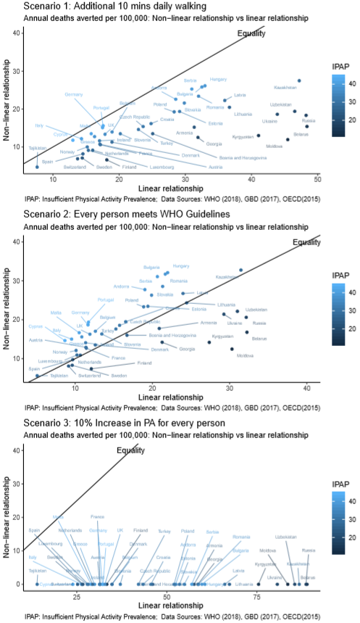

The estimated deaths averted because of increased population physical activity is a single outcome, or consequence, which is useful when comparing interventions which all have the sole aim of reducing mortality. In order to allow for trade-offs in decision making between health and non-health outcomes the HEAT tool monetises the deaths averted using the Value of a Statistical Life (VSL) (Viscusi & Aldy, 2003), giving an estimate in terms of monetary benefit. Figure 2 below shows the net monetary benefit associated with Scenario 1, in our base case using a power transformation of 0.375. The monetary benefits tend to be higher in countries with higher insufficient physical activity prevalence and higher VSL (e.g. Ireland ($590.70), the UK ($538.70) and Luxemburg ($634.16)) and significantly lower in countries with lower VSL and/or lower physical inactivity prevalence such as Ukraine ($34.80) and Moldova ($26.04), this results in marked differences between the West and East Europe.

Figure 2. Annual Monetary Benefit of an additional 10 minutes daily walking for 44 European Countries, in 2016 USD.

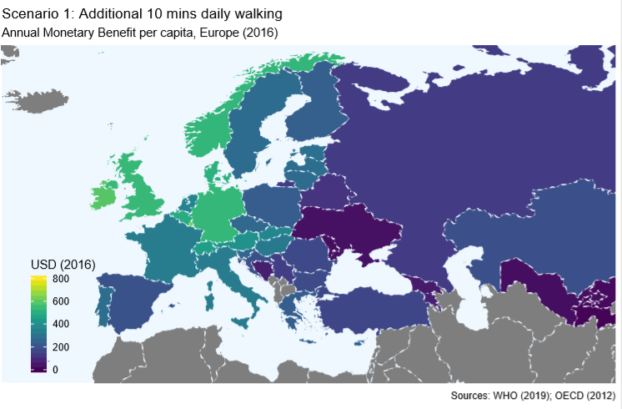

# Discussion

Increasing population physical activity seems likely to yield benefits in health, wellbeing & productivity worldwide (Hafner et al., 2019). However, trade-offs often exist between increasing population physical activity and other outcomes. It is therefore important to have a robust method to value the benefits of increased physical activity. The HEAT is an example of such a method, often used by transport planners to incorporate the benefits of physical activity into transport planning (Kahlmeier et al., 2010).

We describe an adaption to the current HEAT physical activity module which applies a non-linear dose response relationship between physical activity and mortality risk to estimated country specific baseline distributions of physical activity. The new method is more sensitive to interventions which increase the activity levels of the least active, and less sensitive to interventions which increase the activity levels of the most active. This means that similar scenarios may be likely to yield less health benefit in more active countries. Since countries with higher GDP tend to have a higher Value of a Statistical Life (OECD, 2012) and higher prevalence of insufficient physical activity (Guthold et al., 2018), the estimated net monetary benefit tends to be higher in western Europe than eastern Europe.

There are numerous limitations of this analysis. Firstly, the method used to estimate the baseline distributions of physical activity in each of the HEAT countries (from Hafner et al. 2019) assumes that the shape of the physical activity distribution is somewhat similar in every country, and that it is possible to use the prevalence of insufficient physical activity in a country to estimate the distribution of physical activity levels relative to some generic distribution. Comparing the distributions estimated by this method (and provided in the supplementary material) with more detailed data-sets is an obvious next step. It is likely that the method is reliable for similar countries (e.g. the UK and Germany) but may not be reliable where culture differs (e.g. UK and Chad).

A further limitation is that applying transformations to the physical activity distribution is not simple to explain to stakeholders. The use of non-linear dose response effects will inevitably require more carefully planned explanation. The trade-off between complexity and accuracy is a difficult one, and further work to determine whether stakeholders understand the use of distributions will likely be a determining factor as to the feasibility of adapting the HEAT tool.

Finally, none of the work discussed here addresses the more fundamental limitations of the HEAT model, including the quality of life implications of physical activity. Since much of the benefit of physical activity is associated with improvement in quality rather than length of life, addressing this is essential.

# Conclusions

The use of a linear dose response relationship has been identified by the HEAT team as a practical solution to the lack of country specific physical activity distributions for each country. The method described in this study provides a means of incorporating a non-linear dose response relationship, aligning with the epidemiological literature. The change would result in smaller (larger) estimated benefits for interventions which increase physical activity in populations that are already more (less) active. However, an important next step is to validate the method used to derive country specific physical activity distributions against representative national level data-sets.

# References

Arem, H., Moore, S.C., Patel, A., Hartge, P., De Gonzalez, A.B., Visvanathan, K., Campbell, P.T., Freedman, M., Weiderpass, E., Adami, H.O. and Linet, M.S., 2015. Leisure time physical activity and mortality: a detailed pooled analysis of the dose-response relationship. *JAMA internal medicine*, *175*(6), pp.959-967.

Guthold R, Stevens GA, Riley LM, Bull FC. Worldwide trends in insufficient physical activity from 2001 to 2016: a pooled analysis of 358 population-based surveys with 1·9 million participants. Lancet Glob Health 2018

Hafner, M., Yerushalmi, E., Phillips, W.D., Pollard, J., Deshpande, A., Whitmore, M., Millard, F., Subel, S. and Van Stolk, C., 2019. The economic benefits of a more physically active population: An international analysis.

NHS Digital. 2016. Health Survey for England. London, UK. <https://digital.nhs.uk/data-and-information/publications/statistical/health-survey-for-england/health-survey-for-england-2015#resources>

Kahlmeier, S., Racioppi, F., Cavill, N., Rutter, H. and Oja, P., 2010. “Health in all policies” in practice: guidance and tools to quantifying the health effects of cycling and walking. *Journal of Physical Activity and Health*, *7*(s1), pp.S120-S125.

Kahlmeier, S., Cavill, N., Dinsdale, H., Rutter, H., Gotschi, T., Foster, C. and Racioppi, F., 2011. Health economic assessment tools (HEAT) for walking and for cycling.

Kahlmeier, S., Götschi, T., Cavill, N., Castro Fernandez, A., Brand, C., Rojas Rueda, D., Woodcock, J., Kelly, P., Lieb, C., Oja, P. and Foster, C., 2017. Health economic assessment tool (HEAT) for walking and for cycling. Methods and user guide on physical activity, air pollution, injuries and carbon impact assessments.

Kelly, P., Kahlmeier, S., Götschi, T., Orsini, N., Richards, J., Roberts, N., Scarborough, P. and Foster, C., 2014. Systematic review and meta-analysis of reduction in all-cause mortality from walking and cycling and shape of dose response relationship. *International journal of behavioral nutrition and physical activity*, *11*(1), p.132.

Koivusalo, M., 2010. The state of Health in All policies (HiAP) in the European Union: potential and pitfalls. *Journal of Epidemiology & Community Health*, *64*(6), pp.500-503.OECD. Publishing and Organisation for Economic Co-operation and Development, 2012. *Mortality risk valuation in environment, health and transport policies*. OECD Publishing.

Minton, J., Dimairo, M., Everson-Hock, E., Scott, E. and Goyder, E., 2013. Exploring the relationship between baseline physical activity levels and mortality reduction associated with increases in physical activity: a modelling study. *BMJ open*, *3*(10), p.e003509.

MDB (European detailed mortality database) [online database]. Copenhagen: WHO Regional Office for Europe; 2017 (http:// data.euro.who.int/dmdb, accessed 18 October 2017).

Viscusi, W.K. and Aldy, J.E., 2003. The value of a statistical life: a critical review of market estimates throughout the world. *Journal of risk and uncertainty*, *27*(1), pp.5-76.

World Health Organization, 2014. Health in all policies: Helsinki statement. Framework for country action.

Woodcock, J., Franco, O.H., Orsini, N. and Roberts, I., 2010. Non-vigorous physical activity and all-cause mortality: systematic review and meta-analysis of cohort studies. *International journal of epidemiology*, *40*(1), pp.121-138.

# Appendices

Appendix A.

<<< To be completed >>>

Relative risk using linear & non-linear dose response functions with different power transformations:

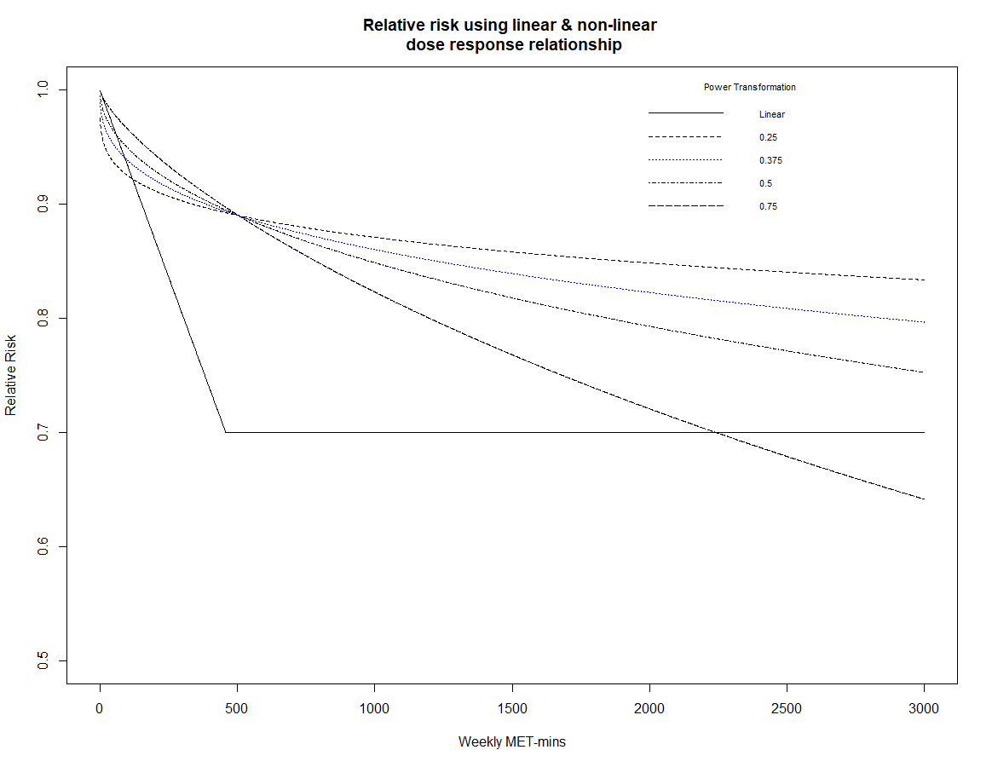

**Scenario 1: 10 minutes additional daily walking per individual (log-linear t= 0.375)**

|  |  |  |
| --- | --- | --- |
| Country | Deaths Averted per 100,000 | Monetary Benefit USD (2016) |
| ISO3 Code | Country | Non-linear | Linear | Non-linear | Linear |
| AND | Andorra | 22.59 | 28.53 | 566.46 | 715.28 |
| ARM | Armenia | 15.2 | 31.32 | 70.25 | 144.73 |
| AUT | Austria | 10.73 | 17.07 | 402.81 | 640.97 |
| BLR | Belarus | 15.4 | 48.36 | 119.7 | 375.83 |
| BEL | Belgium | 13.95 | 18.91 | 497.52 | 674.18 |
| BIH | Bosnia and Herzegovina | 13.5 | 25.05 | 65.45 | 121.45 |
| BGR | Bulgaria | 25.83 | 32.49 | 182.65 | 229.73 |
| HRV | Croatia | 16.16 | 24.8 | 191.03 | 293.19 |
| CYP | Cyprus | 11.78 | 12.99 | 252.61 | 278.59 |
| CZE | Czech Republic | 15.38 | 23.61 | 266.02 | 408.27 |
| DNK | Denmark | 11.28 | 18.89 | 512.62 | 858.76 |
| EST | Estonia | 19.36 | 29.11 | 290.45 | 436.63 |
| FIN | Finland | 6.59 | 18.12 | 238.62 | 655.75 |
| FRA | France | 10.58 | 17.15 | 339.8 | 550.81 |
| GEO | Georgia | 12.51 | 31.88 | 53.24 | 135.66 |
| DEU | Germany | 15.09 | 17.47 | 532.74 | 616.74 |
| GRC | Greece | 12.73 | 16.27 | 234.98 | 300.39 |
| HUN | Hungary | 26.14 | 32.95 | 326.56 | 411.55 |
| IRL | Ireland | 11.63 | 17.01 | 590.72 | 864.12 |
| ITA | Italy | 12.17 | 14.29 | 336.98 | 395.54 |
| KAZ | Kazakhstan | 27.48 | 47.19 | 193.09 | 331.59 |
| KGZ | Kyrgyzstan | 13.01 | 41.04 | 18.63 | 58.77 |
| LVA | Latvia | 22.27 | 35.94 | 288.58 | 465.75 |
| LTU | Lithuania | 20.46 | 36.64 | 275.18 | 492.81 |
| LUX | Luxembourg | 9.12 | 15.32 | 634.16 | 1065.27 |
| MLT | Malta | 13.49 | 15.76 | 270.2 | 315.61 |
| MDA | Moldova | 11.94 | 45.45 | 26.04 | 99.17 |
| NLD | Netherlands | 9.14 | 15.98 | 356.74 | 623.84 |
| NOR | Norway | 10.01 | 15.16 | 529.35 | 801.92 |
| POL | Poland | 19.27 | 28.29 | 232.73 | 341.71 |
| PRT | Portugal | 15.61 | 17.57 | 285.34 | 321.2 |
| ROU | Romania | 23.4 | 31.98 | 178.51 | 243.95 |
| RUS | Russia | 18.34 | 48.22 | 142.53 | 374.79 |
| SRB | Serbia | 25.28 | 30.96 | 148.25 | 181.51 |
| SVK | Slovakia | 21.59 | 29.83 | 369.94 | 511.07 |
| SVN | Slovenia | 13.49 | 20.16 | 262.98 | 393.05 |
| ESP | Spain | 8.18 | 14.51 | 205 | 363.73 |
| SWE | Sweden | 7.09 | 14.41 | 282.85 | 575.09 |
| CHE | Switzerland | 6.89 | 13.7 | 444.64 | 884.69 |
| TJK | Tajikistan | 4.68 | 7.59 | 6.71 | 10.87 |
| TUR | Turkey | 14.61 | 22.89 | 168.25 | 263.62 |
| GBR | UK | 13.35 | 17.85 | 538.7 | 720.33 |
| UKR | Ukraine | 18.62 | 43.87 | 34.81 | 82 |
| UZB | Uzbekistan | 19.4 | 46.51 | 27.78 | 66.6 |

**Scenario 2: 10 minutes additional daily walking per individual (log-linear t= 0.375)**

|  |  |  |  |  |  |  |
| --- | --- | --- | --- | --- | --- | --- |
|  | Country | Deaths Averted per 100,000 | Monetary Benefit USD (2016) | | Country | |
|  | ISO3 Code | Country | DRF | Lin | DRF | Lin |
| 1 | AND | Andorra | 27.73 | 19.01 | 695.3 | 476.65 |
| 2 | ARM | Armenia | 17.76 | 20.87 | 82.05 | 96.44 |
| 3 | AUT | Austria | 12.91 | 11.38 | 484.92 | 427.13 |
| 4 | BLR | Belarus | 16.78 | 32.22 | 130.45 | 250.45 |
| 5 | BEL | Belgium | 17.04 | 12.6 | 607.64 | 449.27 |
| 6 | BIH | Bosnia and Herzegovina | 16.02 | 16.69 | 77.67 | 80.93 |
| 7 | BGR | Bulgaria | 31.72 | 21.65 | 224.29 | 153.09 |
| 8 | HRV | Croatia | 19.49 | 16.53 | 230.45 | 195.38 |
| 9 | CYP | Cyprus | 14.65 | 8.66 | 314.09 | 185.65 |
| 10 | CZE | Czech Republic | 18.56 | 15.73 | 320.9 | 272.06 |
| 11 | DNK | Denmark | 13.52 | 12.59 | 614.44 | 572.26 |
| 12 | EST | Estonia | 23.44 | 19.4 | 351.64 | 290.96 |
| 13 | FIN | Finland | 7.39 | 12.07 | 267.48 | 436.98 |
| 14 | FRA | France | 12.69 | 11.43 | 407.69 | 367.05 |
| 15 | GEO | Georgia | 14.22 | 21.25 | 60.48 | 90.4 |
| 16 | DEU | Germany | 18.68 | 11.64 | 659.26 | 410.99 |
| 17 | GRC | Greece | 15.59 | 10.84 | 287.8 | 200.17 |
| 18 | HUN | Hungary | 32.1 | 21.96 | 400.93 | 274.25 |
| 19 | IRL | Ireland | 14.09 | 11.34 | 715.63 | 575.84 |
| 20 | ITA | Italy | 15.02 | 9.52 | 415.87 | 263.58 |
| 21 | KAZ | Kazakhstan | 32.76 | 31.45 | 230.22 | 220.97 |
| 22 | KGZ | Kyrgyzstan | 14.19 | 27.35 | 20.32 | 39.16 |
| 23 | LVA | Latvia | 26.74 | 23.95 | 346.63 | 310.37 |
| 24 | LTU | Lithuania | 24.33 | 24.42 | 327.21 | 328.4 |
| 25 | LUX | Luxembourg | 10.93 | 10.21 | 759.87 | 709.88 |
| 26 | MLT | Malta | 16.67 | 10.5 | 333.8 | 210.32 |
| 27 | MDA | Moldova | 12.46 | 30.29 | 27.18 | 66.08 |
| 28 | NLD | Netherlands | 10.9 | 10.65 | 425.33 | 415.72 |
| 29 | NOR | Norway | 12.1 | 10.1 | 640.12 | 534.39 |
| 30 | POL | Poland | 23.33 | 18.85 | 281.75 | 227.71 |
| 31 | PRT | Portugal | 19.36 | 11.71 | 354 | 214.04 |
| 32 | ROU | Romania | 28.56 | 21.31 | 217.87 | 162.57 |
| 33 | RUS | Russia | 20.61 | 32.14 | 160.18 | 249.75 |
| 34 | SRB | Serbia | 31.08 | 20.63 | 182.21 | 120.95 |
| 35 | SVK | Slovakia | 26.31 | 19.88 | 450.79 | 340.57 |
| 36 | SVN | Slovenia | 16.34 | 13.43 | 318.62 | 261.92 |
| 37 | ESP | Spain | 9.75 | 9.67 | 244.37 | 242.38 |
| 38 | SWE | Sweden | 8.31 | 9.6 | 331.47 | 383.23 |
| 39 | CHE | Switzerland | 8.1 | 9.13 | 522.95 | 589.55 |
| 40 | TJK | Tajikistan | 5.62 | 5.06 | 8.04 | 7.24 |
| 41 | TUR | Turkey | 17.62 | 15.26 | 202.92 | 175.67 |
| 42 | GBR | UK | 16.28 | 11.89 | 657.31 | 480.02 |
| 43 | UKR | Ukraine | 21.41 | 29.24 | 40.02 | 54.64 |
| 44 | UZB | Uzbekistan | 22.16 | 30.99 | 31.73 | 44.38 |

**Scenario 3: 10 minutes additional daily walking per individual (log-linear t= 0.375.)**